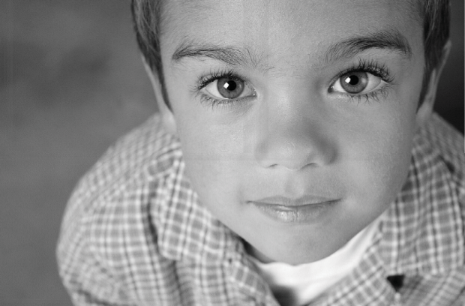
Will the Children Have Other Challenges?
What You Should Know About Childhood Apraxia of Speech

Every child deserves a voice.
Many children with CAS have fine motor skill delays and/or sensory processing difficulties. Some children may experience learning challenges for school-related areas such as reading, spelling, or writing. Children who experience these issues will need assistance from other professionals in fields such as occupational therapy, developmental/ behavioral pediatrics, and special education.
Often other issues may not be readily apparent when the child is first diagnosed with apraxia of speech. Teachers and parents should be vigilant in observing over time for any other issues and seeking help when appropriate and as soon as possible.

Where Can I Learn More About CAS?

Apraxia Kids is the only national nonprofit organization dedicated exclusively to the needs of children with apraxia of speech and their families. Apraxia Kids’ widely acclaimed website, Apraxia-Kids.org, is a wealth of information on all subjects related to children with apraxia and the help that they need.

For more information,
© 2018. Apraxia Kids. All Rights Reserved.
Reprints for personal, non-commercial use only. Otherwise, reproduction is prohibited without the ex- pressed permission of Apraxia Kids.
visit: http://www.apraxia-kids.org
About Apraxia Kids

Apraxia Kids is a 501(c)3 public charity with a mission to improve the system of sup- ports in the lives of children with apraxia so that each child is afforded their best opportunity to develop speech. Our goals are to:

- Provide information, support and resources for children, families, & professionals

- Create and support networking and partnership opportunities for parents and professionals

- Facilitate better public policy and services for children affected by CAS

- Provide education and training for parents and professionals through workshops, seminars, webinars and conferences

- To provide research funding and support on effective treatments for apraxia and to sponsor scientific re- search symposiums to advance the science that is known about the underlying causes of apraxia and treatments.

Apraxia Kids
1501 Reedsdale St, Suite 202 Pittsburgh, PA 15233
Phone: 412-343-7102
Internet: Apraxia-Kids.org
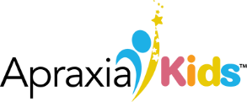

What is Childhood Apraxia of Speech?
Childhood Apraxia of Speech (CAS) is considered a neurological speech disorder that affects a child’s ability to clearly and correctly produce syllables and words. The most obvious thing that others notice is that the child has significantly limited and/or unclear speech.

Who Can Diagnose CAS?

Because CAS is a very complicated speech disorder, the best professional to diagnose it is an experienced speech- language pathologist (SLP). Other speech or language disorders also may cause limited or unclear speech, thus a SLP is the correct professional to diagnose because they have extensive study and experience in detecting the differences between various speech or language problems.

What Causes It?

Currently, all of the causes of CAS are not known. Most often no specific cause is found. These instances are called “idiopathic” in that we just don’t know why the child has this difficulty. However, some children may have CAS as a part of a larger neurological diagnosis or as part of a genetic, metabolic, or mitochondrial disorder.

Why Is It Hard For The Children To Speak?
The act of speaking is a highly sophisticated one! It involves processes of our brain and also involves muscles of the mouth, face, tongue, and soft palate, as well as all of the pathways in between the brain and the muscles.

We start with an idea of what we want to say. Then, subconsciously, we have to correctly assemble the string of sounds and words. Next, we must create a movement plan or “program” that is associated with those sounds and words. Along with planning for which speech muscles should move and in what order, we must assign the correct timing and force for activating the muscles needed to produce the speech. Finally we transmit those speech movement plans to the actual muscles that help us speak.

This all happens in a time shorter than the blink of an eye! It is thought that children with apraxia of speech have difficulty in creating, transmitting or storing the speech movement plans.

What Helps Children With Apraxia of Speech?

Primarily, children with CAS require frequent and intensive individual speech therapy from an experienced SLP. How much and how often that a child receives speech therapy will depend on each individual child, but the more severely the child is affected, the greater the need for frequent and intensive speech therapy. As children improve (which most will with appropriate therapy), less frequent individual speech therapy is needed.
Speech therapy for children with CAS is focused on providing the child with a great number of opportunities to practice planning, programming and then producing accurate movements for speech. Additionally, children with CAS will likely need to work on other language and communication skills during speech therapy. Some children will learn a bit of sign language or use a communication device while they continue to work on their speech skills.
Parents or caregivers need to be highly involved in their child’s speech therapy goals. They serve as important extenders of speech goals, enabling the child to gain more practice opportunities than they could otherwise. Parents also can help model appropriate interactions for others and how to best support the child’s communication attempts.
Children with CAS also need the patience and support of other important people in their lives. Caring extended family, friends and teachers can demonstrate support by learning the best ways to support the child’s speech attempts; not pressuring the child to speak; providing time and loving patience when the child wants to speak; and affirming the child’s efforts and intrinsic worth, value and ability.

Even very young children with CAS are often keenly aware of how difficult speech is for them. With appropriate professional help and support from family and friends, they hopefully can and will persist in their efforts and ultimately experience success.

© 2018. Apraxia Kids. All Rights Reserved.

