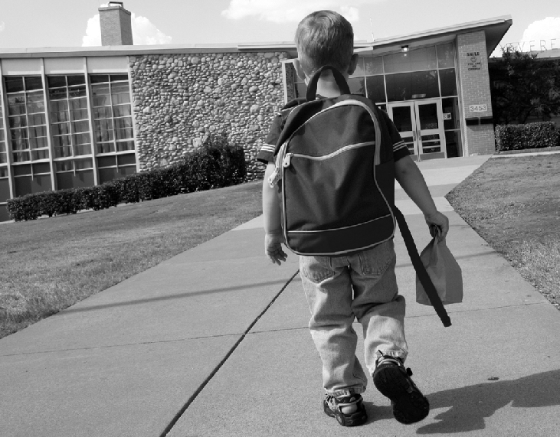

Dear Teacher,
My Child Has Apraxia

This year you'll be having my very special child in your class. When you look at my child, you will see eyes that light up and are full of life. My child has many wonderful abilities and talents. He or she looks like the other children in your classroom. But my child has lived with a lot of silence and a great struggle to communicate. My child has Apraxia of Speech.

Childhood Apraxia of Speech is a speech disorder that makes it difficult for my child to correctly pronounce syllables and words. Children with apraxia know what they want to say. The words are in their heads but often the child is not able to produce the words clearly.

For unknown reasons, children with apraxia have great difficulty planning and producing the precise, specific series of movements of the tongue, lips, jaw and palate that are necessary for intelligible speech. As one expert has said, “The problem occurs when the brain tries to tell the muscles what to do -- somehow that message gets scrambled. It's like trying to watch cable TV stations without the right descrambler. There is nothing wrong with the TV station, and nothing wrong with your set. It's just that your set can't read the signal that the station is sending out. The child must figure out how to somehow unscramble the mixed messages her/his brain is sending to her/his muscles”.

Children with apraxia, however, do understand language and speech. Yet others might mistake and misjudge their unclear speech or quietness as a lack of intelligence. Many children with apraxia experience a great sense of failure and frustration in their attempts to communicate. Some children grow even quieter; others may act out their frustration. Children with apraxia need the support of teachers and parents.

Each child with apraxia is a unique individual, with their own set of abilities, needs, and challenges. However, one common theme is that for some period of time, children with apraxia of speech need frequent and intensive speech therapy that is targeted to their greatest challenge so that they can learn to accurately produce syllables, words, and sentences. These children truly need the services of the Speech-Language Pathologist (SLP). The SLP can work with you to help create a way for my child to communicate with you and classmates, demonstrate what he/she is learning in your class, and to continue improving his/her speech ability and communication. In addition to actual speech skills, at some point of time it is likely that my child will also need to work on expressive language and conversational skills.

Thank you for taking the time to read a little bit about my child’s speech disability. On the back of this sheet are just a few ideas about what can help my child in your classroom.
Please let me know if there is anything I can do to help you better understand my child and his/her needs.

What you can do:
Letter to a Teacher: My Child Has Apraxia

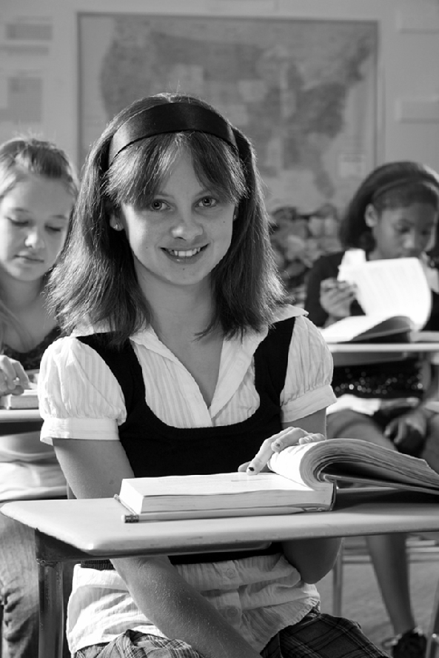
- A speech-language pathologist (SLP) needs to help my child learn to speak with more ease and clarity. It will help my child if you communicate frequently with the SLP and determine if there are things that you can do in the classroom to help my child communicate and practice speech.

- Try to create a tension-free and interesting “communication environment” for my child. Encourage but do not insist he/she try to speak. Praise his/her attempts at speech, if only for effort
Please know that sometimes my child might not respond or might respond “I don’t know” as a way to help themselves get out of a difficult communication challenge.

- Be patient. Sometimes the fast pace of others can leave my child out of the experience although he/she may be able to successfully
communicate if others just offer a bit more time and patience.

- Watch for and even create opportunities to help my child make friends. It can be difficult for a child with apraxia to “break into” social communication and situations. A supportive and nurturing teacher can surely help. No child should be lonely and all children need a friend.

- Intervene immediately in any situations that involve bullying or teasing. Reassure my child that you are his/her supporter and advocate and that no teasing is acceptable.

- Be aware that sometimes children with apraxia are also physically uncoordinated, making competitive sports or even drawing, cutting, and other motor tasks difficult. If you notice some- thing, please do bring it to my attention so we can work together to help my child.

- Keep alert for any other signs of learning difficulty. Sometimes children with apraxia have difficulty learning to read, write, spell or do math.

- My child may need to communicate in alternative ways. Often sign language, augmentative devices, or pictures can help my child as a bridge to clear speech, helping us gain insight into his or her thoughts.

- Most of all, please include me as your partner. I want very much to help my child and to do everything possible to support you as my child’s teacher. I hope we will always reach out to communicate and share information with each other for the benefit of my child.

Teachers are very important people in the life of a child with apraxia of speech. Thank you for your time in reading this handout. Apraxia Kids is a 501c3 public charity and is dedicated exclusively to the needs and interest of children with apraxia of speech and their families. To learn more about Childhood Apraxia of Speech, please visit the online home of Apraxia Kids at Apraxia-Kids.org.

