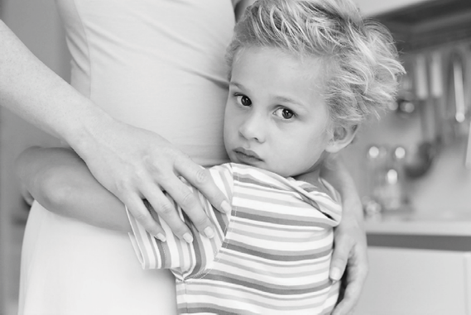

If I Could Only Tell You,
I Would Say ...

What would a young child with apraxia of speech say if they could and if talking wasn’t so difficult? What would they like to tell us? Maybe, some of the following:
Childhood Apraxia of Speech

- I feel nervous that you might ask me my name and I won’t be able to say it.
- I have the answer in my head but I need you to give me more time to answer so that I can say my words the best that I know how.
- I really want you to know that I am smart even though I don’t talk well yet.
- I want to hide sometimes when you ask me to use my words.
- It can be scary to be with new people who don’t understand what I want or need.
- It feels bad when kids say that I talk funny.
- Sometimes I point or try to use my hands to “talk” and show you what I mean.
- I feel happy when you let me know that you are proud of how I am learning to talk.
- Sometimes I need a big person to help include me as one of the gang.
- I need you to explain to the kids that even if I can’t talk well, I still want to play.
- There are times it just feels easier to be by myself so I won’t have to say things over and over again.
- Sometimes I just don’t know what to do when I cannot say the words. I might get upset or mad or sad because it is hard for me.
- There are things that I can do really great and it feels good when some‐ one notices those things.

© 2018. Apraxia Kids. All Rights Reserved.
Reprints for personal, non commercial use only. Otherwise, reproduction of materials in any form is prohibited except with the prior written permission of Apraxia Kids, Cardello Building, 1501 Reedsdale St, Suite 202, Pittsburgh PA 15233.
Internet: http://www.apraxia‐kids.org

