Treatment Approaches for Children with Childhood Apraxia of Speech (CAS)

Childhood apraxia of speech (CAS) is a neurological motor speech disorder in which a child has difficulty rapidly, accurately, and consistently producing and timing the movement sequences needed to produce speech. CAS is not due to having weak muscles for speech. A treatment plan for a child with CAS should be based on the nature of the disorder and on the individual needs and strengths of the child. Below are approaches often successfully used in treating the speech impairments of children with CAS. (Note: Often these children also need additional approaches that tar- get other communication difficulties such as expressive and receptive language skills.)
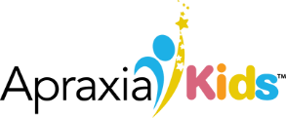
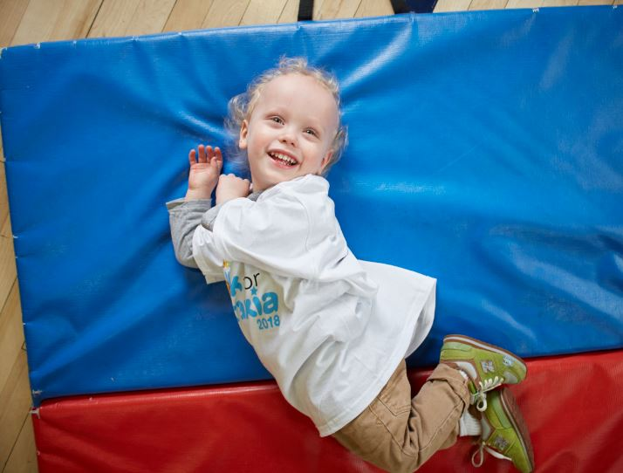
FACT
SHEET

Treatment Approaches for Children with Childhood Apraxia of Speech

Apraxia Kids is the only national nonprofit 501(c)3 public charity exclusively dedicated to improving the lives of children and families affected by apraxia.

Principles of Motor Learning
Because speech is a highly skilled motor task and CAS expresses itself as a speech movement disorder, the principles of motor learning are often incorporated into a clinician’s treatment plan when treating children with CAS. These principles of motor learning tell us that the ability to perform a skilled action gets better with practice, and that certain types of practice will be most effective, as outlined below:

- Practice makes perfect: The most important aspect to motor learning is practice. If a child practices the correct movement sequence over and over again, motor learning will occur. Children with CAS need frequent, intensive practice opportunities.
- Preparation is beneficial: Practice is best if a child is “ready” before beginning the practice. This involves establishing trust, motivation and focused attention to the speech movement practice tasks.
- Explanations are helpful: Optimal motor learning occurs when the child knows what is being asked of him and why.
- How we distribute practice matters: Practicing only one skill at a time may produce faster learning of that skill, but slower carry over and use of the skill outside of the treatment session. Practicing several skills at the same time may take longer but is believed to yield better carry over to situations outside of treatment.
- Rate influences learning: Slowing the speed of a motor task can facilitate motor learning, but rates that are too slow may interfere with learning the skill.
- Feedback is important: The type, timing and amount of feedback given to a child will greatly impact how quickly and how well he ultimately learns the skill.

These factors, when incorporated into a treatment plan for improving speech motor learning, can help guide decisions on activities and reinforcers, frequency of sessions, instructional methods, number of speech production targets to include in therapy, optimal number of repetitions to elicit within a session, distribution of practice within and across sessions, rate of production of target utterances, and type of feedback provided for the child’s speech attempts.

Treatment Techniques
When individualizing a treatment plan based on a child’s needs and strengths, any of a number of treatment techniques that incorporate the principles of motor learning can be used in order to try to elicit “correct” speech movement gestures. Some traditional approaches are modified for children with CAS to incorporate speech motor learning principles. In everyday use, many of these techniques are combined in speech therapy for children with CAS.

- Multi-sensory cueing techniques use a variety of sensory cues to help the child hear, see, feel, and/or understand the target speech movement gestures being requested of them as they practice words or phrases.
- Integral stimulation approaches use a well-defined and structured hierarchy of speech targets and re- quire the child to imitate utterances (syllables, words, or phrases) modeled by the clinician in a “look, listen, do what I do” approach. In this approach, the child’s auditory attention is focused on listening to the words, and his visual attention is focused on looking at the clinician’s face. Over time as the child’s skills improve, the clinician varies the timing of the child’s repetition and then ultimately works toward the child’s self-initiated correct production of speech targets.
- Progressive approximation and shaping techniques use speech productions that children are currently capable of producing and then, through various forms of feedback and practice, attempt to shape the child’s movement gestures into closer and closer approximations of the target word.
- Phonetic placement techniques provide verbal information and instruction to the child regarding what to physically do with their mouth, tongue, lips, or jaw during speech attempts in order to achieve more accurate articulatory positions for certain sounds that may be difficult for them to produce. However, the main focus of speech therapy is on speech movement sequences.
- Tactile facilitation approaches use touch or manipulation of the head, face, lips and jaw during speech production so that the child can better “feel” and over time remember how to move their articulators correctly in order to produce the speech movements. Assistance is often provided at first and then faded as the child obtains independence at making the movements gestures for speech.
- Prosodic facilitation uses rhythm and melody to provide timing or rhythmic structure within which speech movements can be achieved.
- Gestural cueing involves hand cueing to represent targeted shapes and movements of the articulators.

Again, variations of these approaches are combined together in treating children with CAS. Additionally, because many children with CAS, have co-occurring language related issues, therapy approaches that best address those needs are certain to be included in the overall speech/language treatment plan, though they are not addressed in detail here.

In summary, a well-qualified clinician combines their knowledge of CAS with their knowledge of each individual child in designing treatment plans. The clinician understands the principles of motor learning and uses this knowledge to guide treatment decisions and the choice of techniques to use in order to facilitate speech motor learning for a child. Whatever approach a clinician takes, s/he should be able to describe to a parent why that approach was selected for the child, based on the nature of the disorder and on the child’s individual strengths and needs.

- by Sue Caspari, M.A., CCC/SLP

Detailed descriptions of treatment approaches for children with CAS can be found in: Caruso A.J., Strand E.A. (Eds.). 1999. Clinical Management of Motor Speech Disorders in Children, New York: Thieme.

© Apraxia Kids

1501 Reedsdale St, Suite 202

Pittsburgh, PA 152

