Childhood Apraxia of Speech

Childhood apraxia of speech (CAS) is a neurological motor speech disorder in which a child has difficulty rapidly, accurately, and consistently producing and timing the movement sequences needed to produce speech. CAS is not due to having weak muscles for speech. There are several characteristics that are generally accepted to distinguish CAS from other types of speech delays and disorders.
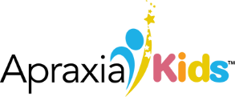
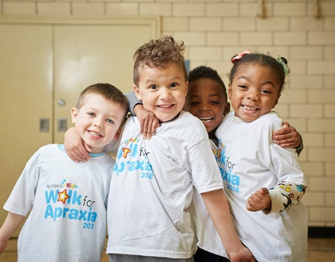
FACT
SHEET
Characteristics and Speech Examples of Childhood Apraxia of Speech

Apraxia Kids is the only national nonprofit 501(c)3 public charity exclusively dedicated to improving the lives of children and families affected by apraxia.

Difficulty achieving, maintaining and moving between articulatory positions:
The child has difficulty consistently moving the speech articulators (i.e.: the lips, tongue, jaw, etc.) exactly where they need to be, when they need to be there. The sound productions may seem to be “half-way” in between one sound or another or have different variations.

Example 1: A child might be able to say /l/ in the word “like”. However, when they say the /l/ in “balloon”, the /l/ might sound more like an /n/ or a /d/ resulting in “banoon” or “badoon”. It’s hard for the child to reproduce the same /l/ sound that he/she could say so well at the beginning of the word “like” because it is in a different place in a differ- ent word and different sounds (and thus different articulatory positions) come before and after the sound, influencing the movements needed for accurately producing /l/.
Example 2: A child may be trying to say “two”, but in their attempt to elevate the tongue tip to make the /t/ sound, they may instead exhibit searching or groping behaviors in which the lips purse, or the tongue protrudes, or the jaw moves in unexpected ways.

Example 3: A child may not be able to get a rounded lip position to start a “w” sound and when he finally does, it falls apart when he adds a vowel sound with the “w”, unless it’s the “oo” vowel, since ‘oo’ is also produced with the lips rounded. So, “way” would be difficult, but “woo” would work.

Difficulty with smooth movement transitions between sounds and syllables: When a child with CAS produces a word, there may be lengthy pauses or breaks between the sounds and/or syllables within the word. This may be due to difficulty coordinating the motor movement of the lips, jaw, and tongue from one sound to the next. Or the child may have a problem coordinating “voicing”, going from one sound that doesn’t need vocal fold vibration, a voiceless sound, to the vowel sounds that do need vocal fold vibration and are “voiced”.

Example 1: A child may be trying to say “hi” or “bye”, but there is a break between the first sound and the vowel resulting in “h -- i” or “b -- ye”.

Example 2: A child may be trying to say the word “dog”, and may effortfully separate each sound, resulting in a production that sounds like “duh” - “awe” - “ug”.

Example 3: A child may pause between sounds and syllables so that words sound “choppy” (“I-want-huh-nee-oz-for-suh-nack” – instead of “I want Honeyo’s for snack”)..

Vowel distortions: The child substitutes vowel sounds in words with sounds that are not recognized as any other English vowel sound. Sometimes the resultant vowel sound will have “properties” of one or several English vowels, and other times it will not sound at all like any vowel you know. This is different from vowel “substitutions” in which other distinct English vowels are substituted for the target vowel. Vowels may be distorted due to reduced coordination of lips, tongue, or jaw, or not building enough muscle tension. Or perhaps there are distortions because the child is reducing the amount of movement needed to get to the vowel or move from the vowel to the following sound.

Example 1: In trying to say “mine”, the child produces vowel sounds that sound more like “men” or “min” or “mon”, but that aren’t accurate enough to represent any true vowel.
Example 2: A child may want to say “two” and end up saying something that sounds more like “tao” with properties of an “ah” and properties of an “o”, or he may end up inserting a vowel-like sound that is not recognized as any “English” vowel.

Example 3: A child uses a neutral, open-mouthed vowel sound similar to “uh” when words get harder like “guhguh” for “glasses” and “wuh” for “clouds”.

Prosodic errors:
The “melody” of the speech pattern is affected, lacking inflection and appropriate stress patterns. A child’s speech may lack expression and sound monotone or robotic.
Example 1: When asked, “Whose toy is this?” the child might say “It’s my toy” but not emphasize the word MY, as is expected when a child is emphatic about indicating possession.

Example 2: A child may separate and place equal stress on syllables within a word. This can result in “over precise” articulation of sounds throughout the word, making the child sound “robotic” with a staccato pattern of speech (i.e. “TO-MA-TO” instead of “toMAdo”).

Example 3: A child may not raise their pitch appropriately at the end of a question so it sounds more like a statement (i.e., NOT adding rising inflection on the /o/ in “go” when asking, “Do you want to go?”).

Inconsistency of error patterns upon word repetition:
When a child repeats the same word, it may sound different each time if the child has not mastered being able to coordinate and time his/her movement gestures for speech in order to produce the word correctly.

Example 1: A child trying to say “puppy” might produce “buppy” then “bumpy” then “pubby” or “pubba”.

Example 2: A child may try to say “two” three times, resulting in “uht”, “oot” and “tuh”.

Example 3: A child tries to produce “go” as ends up saying “ah”, “bah”, and “dah” when asked to repeat it 3 times.

If you are concerned that your child has characteristics of CAS, you may want to seek an evaluation from a speech language pathologist, who is certified by the American Speech Language and Hearing Association (ASHA) and has extra experience in CAS. Speech pathologists often will outline their primary treatment areas in their listings on the ASHA website (www.asha.org). Additionally, the Apraxia Kids website has an SLP Online Directory to find apraxia experts across North America.

by Sue Caspari, M.A., CCC/SLP, with assistance from Becky Baas, M.A., CCC/SLP and
Dave Hammer, M.A., CCC/SLP

© Apraxia Kids

1501 Reedsdale St, Suite 202

Pittsburgh, PA 15233

